CS27 — The Relational Model & Databases
Part 1: Database Design — Scenario: E-Commerce Platform
Burkina Institute of Technology | Computer Science Department

1.1 Identify Your Entities
Our E-Commerce database is designed around six core entities, each representing a distinct real-world object essential to online store operations. Each entity has been carefully defined with its attributes and a primary key that ensures unique identification and efficient data management.
# | Entity | Attributes | Primary Key | PK Justification
1 | Category | category_id, category_name, description | category_id (INT) | Surrogate key ensures stability; category names may change
2 | Product | product_id, category_id (FK), product_name, price, stock | product_id (INT) | Product names can be duplicated; surrogate key guarantees uniqueness
3 | Customer | customer_id, first_name, last_name, email, password, address | customer_id (INT) | Email may change; stable integer ID serves as efficient FK target
4 | Order | order_id, customer_id (FK), order_date, status | order_id (INT) | Each order transaction is unique regardless of customer
5 | Order_Detail | detail_id, order_id (FK), product_id (FK), quantity, unit_price | detail_id (INT) | Junction table resolving M:N; surrogate key simplifies references
6 | Payment | payment_id, order_id (FK), payment_date, amount, method | payment_id (INT) | One order may have multiple payment attempts; each requires ID
Table 1: Entities with attributes and primary key justifications

1.2 Identify All Relationships
The six entities are interconnected through well-defined relationships that reflect the business logic of an e-commerce platform. The many-to-many relationship between Order and Product is resolved through the Order_Detail junction table.
Table A | Table B | Type | Relationship Description | Foreign Key Location
Category | Product | 1 : M | One category contains many products | Product.category_id → Category.category_id
Customer | Order | 1 : M | One customer can place many orders | Order.customer_id → Customer.customer_id
Order | Order_Detail | 1 : M | One order contains many line items | Order_Detail.order_id → Order.order_id
Product | Order_Detail | 1 : M | One product appears in many order details | Order_Detail.product_id → Product.product_id
Order | Payment | 1 : M | One order can have multiple payment records | Payment.order_id → Order.order_id
Table 2: Entity relationships with types and foreign key placements

1.3 Schema Diagram
The schema diagram below presents all six tables with their attributes, primary keys (PK), and foreign key (FK) relationships. The Order_Detail junction table resolves the many-to-many relationship between Order and Product.

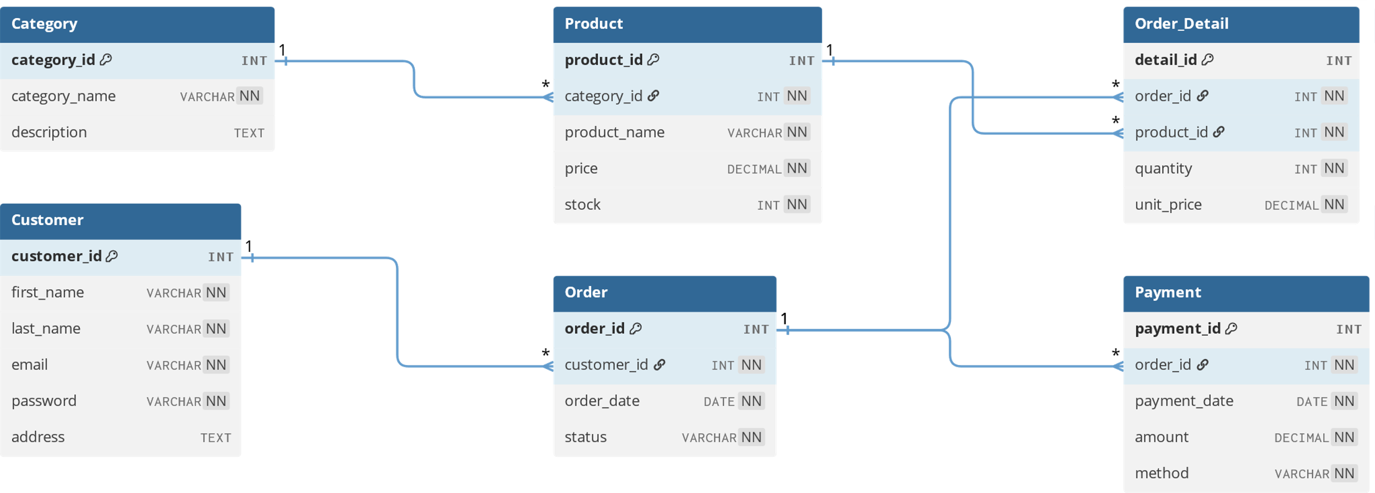
Figure 1: Database schema diagram showing all tables and relationships

1.4 Normalization

Step 0 — Unnormalized Form (UNF)
We begin with a single flat table containing all data in one row per order. This violates 1NF due to repeating groups (product_id_1, product_id_2, etc.) and non-atomic values.
order_id | order_date | cust_id | cust_name | prod_id_1 | prod_name_1 | price_1 | qty_1 | prod_id_2 | ...
1 | 2024-01-15 | 101 | John Doe | P001 | Laptop | 999.99 | 1 | P002 | ...
2 | 2024-01-16 | 102 | Jane Smith | P003 | Mouse | 29.99 | 2 | NULL | ...
Table 3: Unnormalized Form (UNF) with repeating groups

Step 1 — First Normal Form (1NF)
Problem: Repeating groups violate atomicity — product_id_1, product_id_2 store the same type of data in separate columns. Fix: Flatten to one row per (order_id, product_id) pair with composite PK.
order_id* | product_id* | order_date | cust_id | cust_name | prod_name | price | qty
1 | P001 | 2024-01-15 | 101 | John Doe | Laptop | 999.99 | 1
1 | P002 | 2024-01-15 | 101 | John Doe | Mouse | 29.99 | 2
2 | P003 | 2024-01-16 | 102 | Jane Smith | Keyboard | 79.99 | 1
Table 4: First Normal Form (1NF) — flattened with composite PK (order_id, product_id)

Step 2 — Second Normal Form (2NF)
Problem: Partial dependencies exist — customer attributes depend only on cust_id (part of PK), product attributes depend only on product_id (other part of PK). Fix: Extract into separate tables.
Customer Table:
customer_id (PK) | customer_name | email
101 | John Doe | john@email.com
102 | Jane Smith | jane@email.com
Product Table (2NF):
product_id (PK) | product_name | price | category_name
P001 | Laptop | 999.99 | Electronics
P002 | Mouse | 29.99 | Accessories
Order and Order_Detail Tables:
order_id (PK) | customer_id (FK) | order_date
1 | 101 | 2024-01-15
2 | 102 | 2024-01-16
Order_Detail Table:
order_id (FK) | product_id (FK) | quantity
1 | P001 | 1
1 | P002 | 2
Table 5: Second Normal Form (2NF) — partial dependencies removed

Step 3 — Third Normal Form (3NF)
Problem: Transitive dependencies exist — category_name depends on category_id (non-key), not directly on product_id. Payment attributes belong to a separate Payment concept. Fix: Extract Category and Payment into separate tables.
Category Table (extracted from Product):
category_id (PK) | category_name | description
C001 | Electronics | Electronic devices
C002 | Accessories | Computer accessories
Product Table (3NF):
product_id (PK) | category_id (FK) | product_name | price
P001 | C001 | Laptop | 999.99
P002 | C002 | Mouse | 29.99
Payment Table:
payment_id (PK) | order_id (FK) | amount | payment_method
PAY001 | 1 | 1059.97 | Credit Card
PAY002 | 2 | 79.99 | PayPal
Table 6: Payment Table (3NF)

Normalization Summary
Step | Problem Found | Violation | Fix Applied
UNF → 1NF | Repeating groups: product_id_1, product_id_2 in same row | Columns must be atomic and single-valued | Flatten: one row per (order, product) pair
1NF → 2NF | Customer/product attributes depend on partial key | 2NF: non-key attributes must depend on WHOLE PK | Extract Customer, Product, Order_Detail tables
2NF → 3NF | category_name determined by non-key attribute | 3NF: no transitive dependencies | Extract Category and Payment tables
Table 7: Normalization steps summary

